

MARANDA 2025 KCSE PREDICTION
EXPECTED EXAM 1
POWER MECHANICS
447/1
PAPER 1 (THEORY)
TIME: 2½ HOURS

NAME……………………………………………………………………………………..
SCHOOL……………………………………………… SIGN………………………..
INDEX NO……………………………………………. ADM NO……………………

Kenya Certificate of Secondary Education.

INSTRUCTIONS TO CANDIDATES
- Candidates should have the following materials for this examination:
Answer booklets
Drawing instruments
Drawing paper size A4
- This paper has TWO sections: A and B.
- Answer ALL the questions in section A. Answer question 11 and any other THREE questions from section B
- All dimensions are in millimeters unless otherwise stated.
- Candidates may be penalized for not following the instructions given in this paper.

SECTION A (40 marks)
Answer ALL the questions in this section.
1a) State the composition of a soft solder. (1 marks)
- ………………………………………………………………………………………………

- …………………………………………………………………………………………..

b) Define the following terms as applied to engine operation: (3marks)
- Valve lead

………………………………………………………………………………………………..
- Valve lag
…………………………………………………………………………………………………..

- Valve overlap

………………………………………………………………………………………………………

- Pre-ignition

……………………………………………………………………………………………………….

- Steering geometry

……………………………………………………………………………………………………….

- Leading shoe

c) Describe in point form how to repair a dented roof of a vehicle. (5marks)
…………………………………………………………………………………………………………
…………………………………………………………………………………………………………
…………………………………………………………………………………………………………
…………………………………………………………………………………………………………
…………………………………………………………………………………………………………
…………………………………………………………………………………………………………

- Sketch the symbols for each of the following electrical devices: 2marks
- Lamp

- Capacitor

- Diode

- Fuses

.
3 a) Calculate the compression ratio of a single cylinder engine with the following measurements:
- Stroke 100mm:
- Bore 100mm:
- Clearance volume 100cc. ( 3marks)

b) List four tools used in body repair work. (2marks)
i…………………………………………………………………………………………………
ii……………………………………………………………………………………………….
iii………………………………………………………………………………
iv………………………………………………………………………………

4 a) Define the following terms related to materials (2 marks)
- Torsional strength:
…………………………………………………………………………………………………..
…………………………………………………………………………………………………..
- Heat conductivity
……………………………………………………………………………………………………
…………………………………………………………………………………………………….

c) List four major lighting circuits stating their functions (2 marks)
- ………………………………………………………………………………………

- ……………………………………………………………………………………….

- ………………………………………………………………………………………..

- ………………………………………………………………………………………

5. State two conditions which must be fulfilled before soldering is done. (2 marks)

…………………………………………………………………………………………

………………………………………………………………………………………….

6a) State the functions of the following in a vehicle. (3marks)
- Valve train
…………………………………………………………………………………………………………
…………………………………………………………………………………………………………

- Radiator pressure cap
…………………………………………………………………………………………………………
…………………………………………………………………………………………………………

- Distributor
…………………………………………………………………………………………………………
…………………………………………………………………………………………………………

b) State the best method of putting off fire caused by the following: (2 marks)
a) Electrical short circuit
……………………………………………………………………………………….
- Fire wood, paper, and grass.
…………………………………………………………………………………………
- Oil
............................................................................................................................................
- Gases and vapor.
………………………………………………………………………………………...

- Give 2 main reasons why the power mechanics workshop must be well ventilated. (2 marks)

- ………………………………………………………………………………

- ……………………………………………………………………………….

7. Draw the symbols used to represent each of the following machine parts in assembly drawing: (3 marks)
- External screw thread:

- Splined shaft

- Cylindrical tension spring

8. For each of the following spark plug problems, state one possible cause: (2 marks)
i) Wet oily deposit:
……………………………………………………………………………………………..
ii) Sooty black deposits
……………………………………………………………………………………………..

9a) Define the following vehicle electrical terms (2 marks)
- Conductor.
……………………………………………………………………………………………
- Short circuit.
……………………………………………………………………………………………
- Earth.
…………………………………………………………………………………………….
- Open circuit.
……………………………………………………………………………………………

b) State the cause of each of the following noise during welding process: (2 marks)
- Sharp hissing

…………………………………………………………………………………………..
Pop.
- ……………………………………………………………………………………………

10. List four functional /operational requirements of the suspension system. (4 marks)
i) ………………………………………………………………………………………
ii) ………………………………………………………………………………………
iii)……………………………………………………………………………………….
iv)……………………………………………………………………………………………

Answer question 11 and any other THREE questions from this section.
Candidates are advised to spend not more than 25 minutes on question 11.

11. The figure below shows a block drawn in isometric projection.
Draw full size in third angle projection the following views:
- Sectional front elevation along the cutting plane X-X.
- Sectional end elevation along the cutting plane B-B. (15 marks)

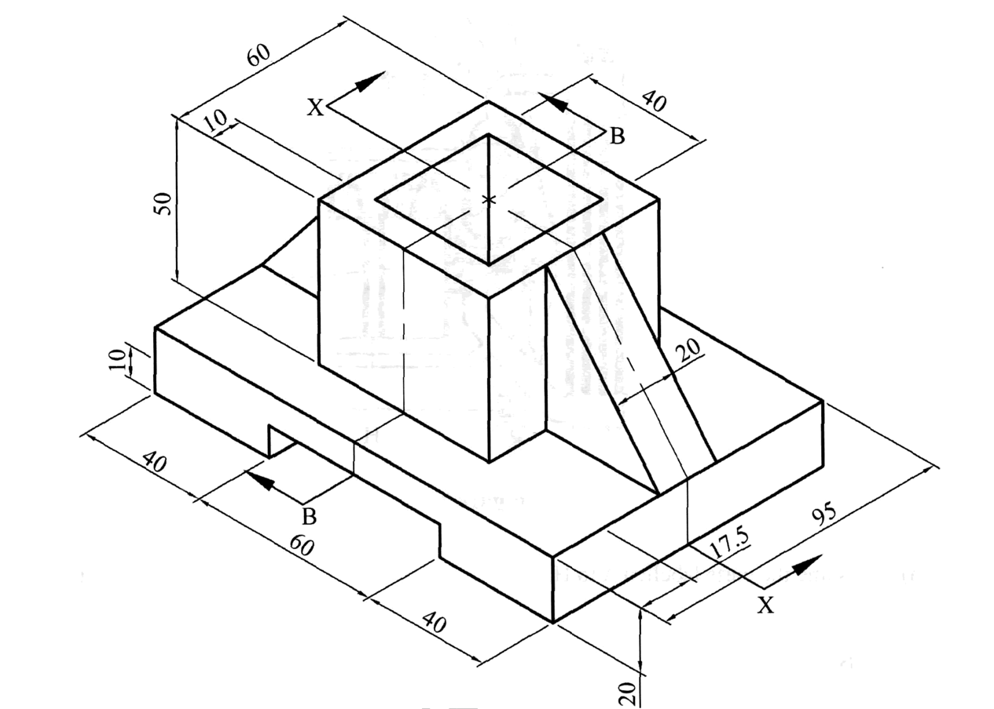

12 a) Outline 3 factors that are used to determine the type of an internal combustion engine
(3marks)
b Differentiate between a “a dead” axle and a “live” axial. (2marks)

- Sketch a section of the disc brake assembly and label any six parts. ( 6marks)

- State two advantages of using disc brakes over drum brakes. (4marks)
i)…………………………………………………………………………………………
ii)…………………………………………………………………………………………

13 a) Explain six (6) operational differences between 2 stroke and 4 stroke cycle petrol engines. (6marks)
…………………………………………………………………………………………………………
…………………………………………………………………………………………………………
…………………………………………………………………………………………………………
…………………………………………………………………………………………………………
…………………………………………………………………………………………………………
…………………………………………………………………………………………………………
…………………………………………………………………………………………………………
…………………………………………………………………………………………………………
…………………………………………………………………………………………………………

- Name 5 types of non-fusion welding rods and each case identify one material they are used to weld in a motor vehicle. (5marks)
…………………………………………………………………………………………………………
…………………………………………………………………………………………………………
…………………………………………………………………………………………………………
…………………………………………………………………………………………………………
…………………………………………………………………………………………………………

c) List 4 thermal processes used in joining metals. (2marks)
…………………………………………………………………………………………………………
…………………………………………………………………………………………………………
…………………………………………………………………………………………………………
…………………………………………………………………………………………………………

d) Name four types of pliers. (2marks)
i) ………………………………………………………………………………..
ii) ……………………………………………………………………………….
iii)……………………………………………………………………………….
iv)………………………………………………………………………………...

14. a) Sketch a standard manual transmission system from the engine to the wheels and label the major parts, stating the function of each part.( 10marks)

- State four causes of tyre wear. (2marks)
…………………………………………………………………………………………………………
…………………………………………………………………………………………………………
…………………………………………………………………………………………………………
…………………………………………………………………………………………………………
c) Illustrate the three types of fits with simple line diagrams. (3marks)
…………………………………………………………………………………………………………
…………………………………………………………………………………………………………
…………………………………………………………………………………………………………
…………………………………………………………………………………………………………

15 a) List five possible field opportunities available to a successive power mechanics graduate. (5marks
…………………………………………………………………………………………………………
…………………………………………………………………………………………………………
…………………………………………………………………………………………………………
…………………………………………………………………………………………………………
…………………………………………………………………………………………………………

c) List down possible causes for: (5marks)
- Headlights dimming when engine is idling.
…………………………………………………………………………….
- Lights will not light.
…………………………………………………………………………….
- Poor illumination
………………………………………………………………………….....
- Wiper motor operates too slowly
………………………………………………………………………………..
- Faint horn sound
………………………………………………………………………………

e) Name three types of mechanical gearboxes and sate the differences between them (5marks)
…………………………………………………………………………………………………………
…………………………………………………………………………………………………………
…………………………………………………………………………………………………………

